PRINTS-A000-EUR-Italy-Rome-Tiber Island-Sadeler-1606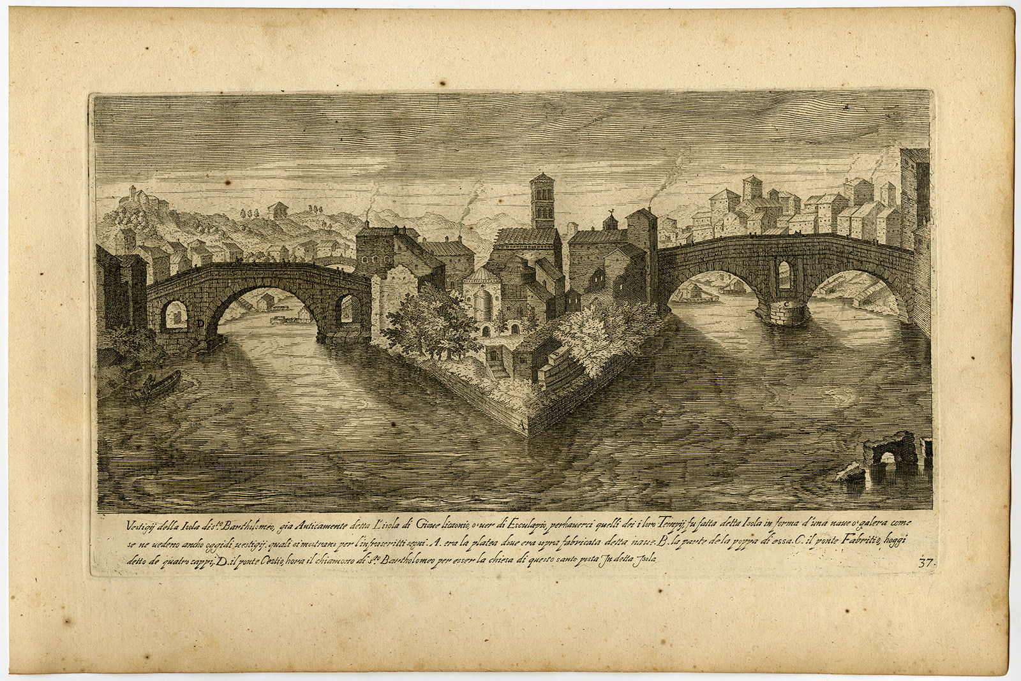



**Description:**From: "Vestigi delle Antichiat di Roma, Tivoli, Puzzuolo et altri Luochi", printed in Prague: 1606. (Views of the antiquities of Rome, Tivoli, Pozzuolo and surroundings.) This antique book contains a beautifully engraved collection of images of Roman ruins and antiquities. This includes the Castel Sant'Angelo, Colosseum, Trajan's Forum, various Arches, Temples, Thermal baths, Mausoleum and Bridges. The final 2 plates are odd plates and represent castle Baarland in the Netherlands and castle Vysehrad near Prague. Plates 42, 43, 46, 49 are after J. Bruegel, 40 after P. Bruegel, 1-38 after Duperac, the others unknown. Ref: Brunet V: 23, Graesse VI: 211, Thieme Becker XXIX: 299, Hollstein XXI p.41: 151-201. Provenance: Ex. Coll. Jean-Conte Devola  
  
**Artists and Engravers:**Made by 'Aegidius Sadeler' after 'E. Duperac'. Aegidius Sadeler (1570-1629) was a Flemish engraver from a large family of engravers. He worked in Prague and Italy. He was a pupil of Hans Sadeler and a brother of Hans and Raphael. He travelled widely. In 1600 he started working exclusively for the emperor's Rudolf II and his sucessors court in Prague. He was a famous artist in his time and named 'the Phoenix of engravers'. The Sadeler family were the largest, and probably the most successful of the dynasties of Flemish engravers that were dominant in Northern European printmaking in the later 16th and 17th centuries, as both artists and publishers. The Sadelers were descended from "chasers," engravers of armor, from Aalst. Jan de Saeyelleer or Sadeleer had three sons, all usually called "Sadeler": Jan I (1550 Brussels - 1600 Brussels or possibly Venice),[3] Aegidius I (c. 1555 Brussels - c. 1609 Frankfurt am Main) and Rafael I (1560/61 Antwerp - 1628 or 1632). Another Sadeler, Marcus or Marco, was a printer and perhaps publisher who was working in Haarlem in c. 1586-87, and is presumed to be a member of the family, though it is not known where he fits in. Jan I was the father of Justus (c. 1572-c. 1620) and Marcus Christoph (active 1614 to after 1650). Aegidius / Gilles was the father of Aegidius / Gilles II (c. 1570-1629 Prague). Rafael I was the father of Rafael II (1584 - 1627 or 1632), Jan II (c. 1588 - 1665 or later) and Filips (c. 1600, active to 1650). Aegidius II was the father of Tobias, who was active from 1670-75 in Vienna. Etienne Duperac (1535-1604) was a French engraver, etcher and architect who was born in Paris. He started his career in Venice and Rome, but returned to France in 1578. He specialized in antiquities, maps and views.

**Subject:**Antique print, titled: 'Vestigii della Isola di sto. Barholomeo […].' - Plate 37: a view of Tiber island, the only island in the river Tiber as it runs through Rome. Bridges span to both banks on the left and right.  
  
**Condition:**Good, given age. Ample margins. Dampstained in the right margin. Some general soiling in the margins and scattered light foxing. A few small spots in the image. General age-related toning and/or occasional minor defects from handling. Please study scan carefully.  
  
**Size** (in cm): The overall size is ca. 33 x 21.8 cm. The image size is ca. 27.5 x 16 cm.  
**Size** (in inch): The overall size is ca. 13 x 8.6 inch. The image size is ca. 10.8 x 6.3 inch.  
  
**Medium:**Engraving on hand laid paper.

ORDER TOTAL

US $285.00